COMPUTER

Your text here

ASSIGNMENT

**PROPOSED TO- AMIT BHATIA SIR**



**CLASS 12 (CS)**

**HOLY ANGEL’S CONVENT SCHOOL**

**MUZAFFARNAGAR (U.P)**

* BY VASVI MITTAL

12 A

**ACKNOWLEDGEMENT**

# I would like to express my special thanks of gratitude to my teacher

# Mr. Amit Bhatia who gave me the golden opportunity to do this wonderful project of COMPUTER SCIENCE.

# Who also helped me in completing my project. I came to know about so many new things I am really thankful to them.

# Secondly I would also like to thank my parents and friends who helped me a lot in finalizing this project within the limited time frame.

# 

# Vasvi Mittal

# 12 A Science

**CERTIFICATE**

This is to certify that “Vasvi Mittal” student of class-12th“A” has successfully completed their

Computer Project under the guidance of “Mr. Amit Bhatia”

Signature

(Mr. Amit Bhatia)



**KOROSUKE – A VIRTUAL ASSISTANT**

## I created a virtual assistant for my board project so that I could get my small jobs done by speaking. So I created an assistant who helps me in doing small things like play song, what is sin 45, searching wikipedia, closing and opening softwares and more other interesting things by just speaking and i named him KOROSUKE



**Examples-**

1. **When I ask what is sin 45 it speak the value of sin 45.**
2. **When I speak Salam khan Wikipedia it give me some imformation about salman khan.**

**CODE -**

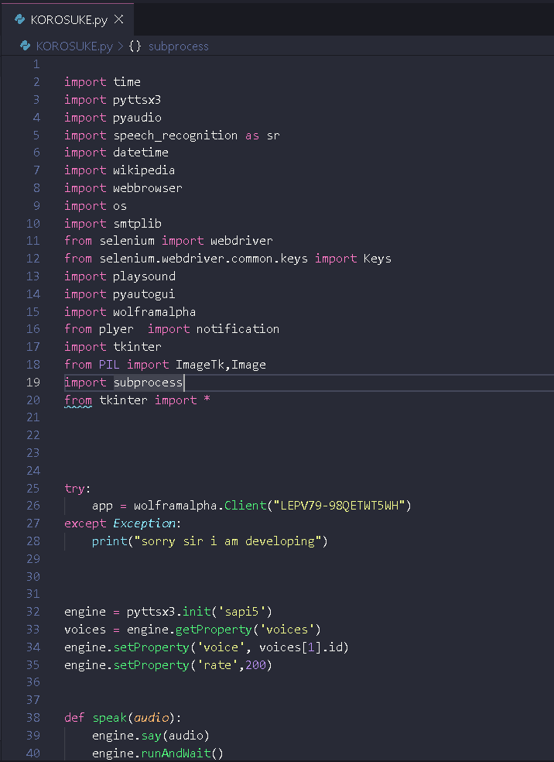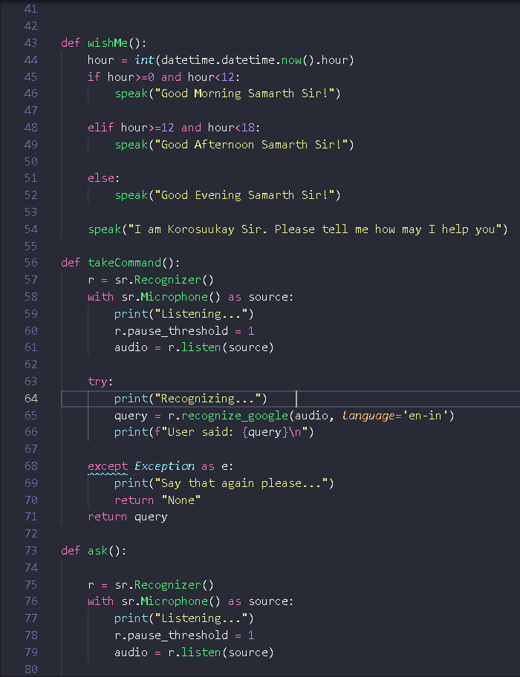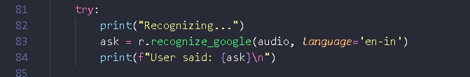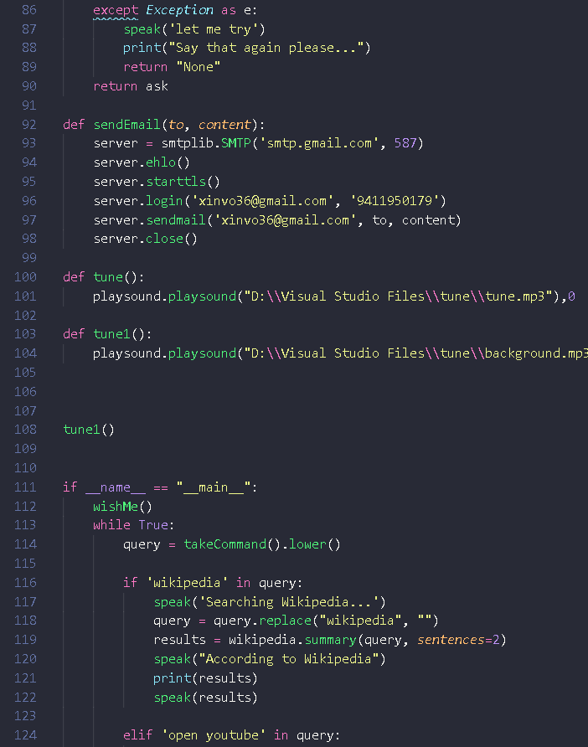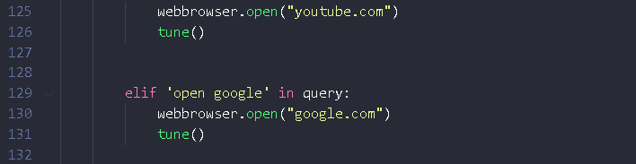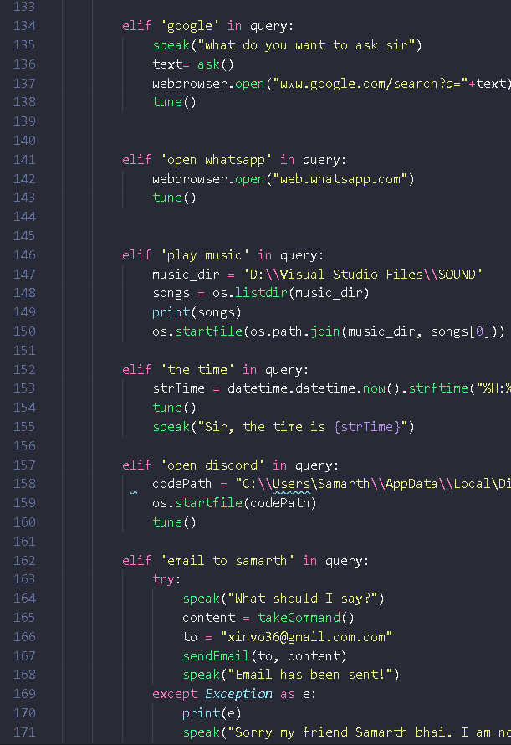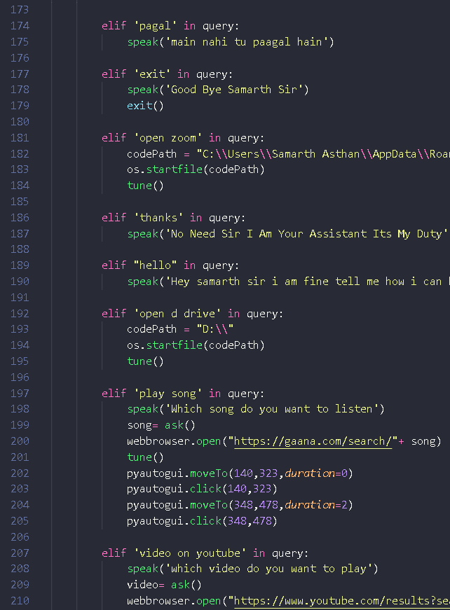

z

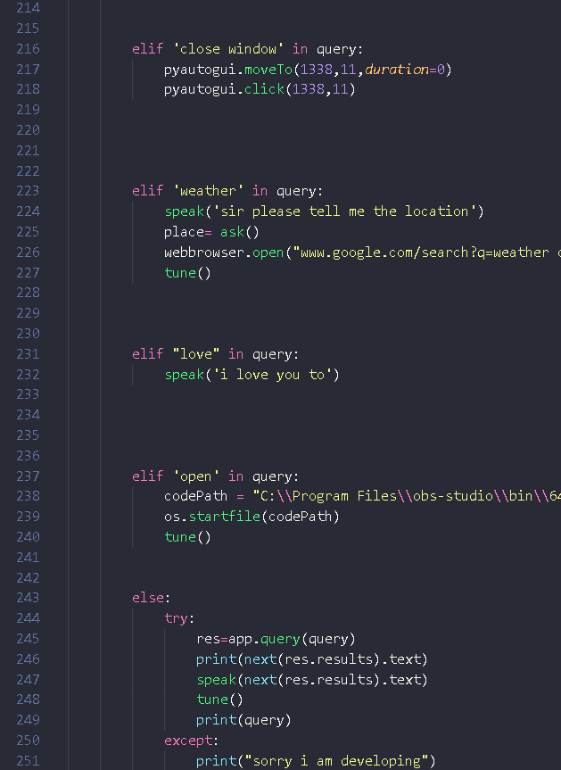

## More About Code-



**Let me Explain how its work. I have used some important Python modules and library like-**

1. **pyttsx3 is a text-to-speech conversion library in Python. Unlike alternative libraries, it works offline, and is compatible with both Python 2 and 3.**
2. **PyAudio provides Python bindings for PortAudio, the cross- platform audio I/O library. With PyAudio, you can easily use Python to play and record audio on a variety of platforms**
3. **Speech recognition, also known as automatic speech recognition (ASR), computer speech recognition, or speech-to- text, is a capability which enables a program to process human speech into a written format.**
4. **In Python, webbrowser module provides a high-level interface which allows displaying Web-based documents to users.**
5. **The smtplib module defines an SMTP client session object that can be used to send mail to any Internet machine with an SMTP or ESMTP listener daemon. ... An SMTP instance encapsulates an SMTP connection.**
6. **PyAutoGUI is a cross-platform GUI automation Python module for human beings. Used to programmatically control the mouse & keyboard. pip install pyautogui.**
7. **Wolfram Alpha is a computational search engine that tends to**



THAT TEXT IS GO THROUGH ALL DEFNIED FUNSTIONS IF IT IS IN THE QUERY

THAT FUNCTION WILL RUN



THEN THE OUTPUT FROM THE FUNCTION WILL BE TAKEN IN TEXT FORM



**evaluate what the user asks. ... Wolfram Alpha will be able to evaluate the question and respond with an answer like “15 degrees centigrade” or “Donald Trump”.**



**Working-**



**VOICE**

**RECOGNISES**



**VOICE IS CONTVERTED INTO TEXT**



AT FINAL THAT OUTPUT TEXT IS CONVERTED INTO SPEECH FORM WHICH WE CAN LISTEN AS OUR FINAL OUTPUT



**Python Conditions and If statements-**

**Python supports the usual logical conditions from mathematics:**



* **Python Programs**

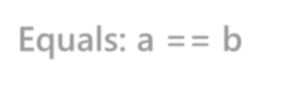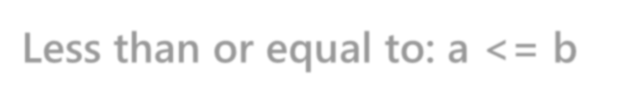

**Equals: a == b Not Equals: a != b Less than: a < b**

**Less than or equal to: a <= b Greater than: a > b**

**Greater than or equal to: a >= b**

**These conditions can be used in several ways, most commonly in "if statements" and loops.**



**An "if statement" is written by using the if keyword.**